Streams assignments

**Pradnya Badole**

**Setup:**

Q1)Create the following classes:

class Fruit { String name; int calories; int price; String color; }

Display the following:

1. Display the fruit names of low calories fruits i.e. calories < 100 sorted in descending order of calories.

2. Display color wise list of fruit names.

3. Display only RED color fruits sorted as per their price in ascending order.

CODE:

**import** java.util.*;

**import** java.util.stream.Collectors;

**import** java.util.stream.Stream;

**class** Fruits {

String name;

**int** calories;

**int** price;

String color;

**public** String getName(){

**return** name;

}

**public** **void** setName (String name) {

**this**.name = name;

}

**public** **int** getCalories () {

**return** calories;

}

**public** **void** setCalories (**int** calories) {

**this**.calories= calories;

}

**public** **int** getPrice() {

**return** price;

}

**public** **void** setPrice(**int** price) {

**this**.price= price;

}

**public** String getColor(){

**return** color;

}

**public** **void** setColor (String color) {

**this**.color= color;

}

@Override

**public** **boolean** equals (Object o) {

**if** (**this** == o) **return** **true**;

**if** (! (o **instanceof** Fruits)) **return** **false**;

Fruits fruits= (Fruits) o;

**return** calories == fruits.calories&&price == fruits.price&&color.equals(fruits.color);

}

@Override

**public** **int** hashCode() {

**return** Objects.*hash*(calories, price, color);

}

**public** **static** Comparator<Fruits>*color1* = **new** Comparator<Fruits>() {

@Override

**public** **int** compare(Fruits o1, Fruits o2) {

**return** o1.getColor().compareTo(o2.getColor());

}

};

**public** **static** Comparator<Fruits>*calories1*= **new** Comparator<Fruits>() {

**public** **int** compare(Fruits f1, Fruits f2){

**return** f2.getCalories()-f1.getCalories();

}

};

**public** **static** Comparator<Fruits>*price1*= **new** Comparator<Fruits>() {

@Override

**public** **int** compare(Fruits o1, Fruits o2){

**return** o1.getPrice()-o2.getPrice();

}

};

}

**public** **class** Assignment1 {

**public** **static** List<String>reverseSort(ArrayList<Fruits>fruits){

List<String>list = **new** ArrayList<>();

ArrayList<Fruits>fruits2 = **new** ArrayList<>();

fruits2 = (ArrayList<Fruits>) fruits.stream().filter((fruits1 -> {**return** fruits1.getCalories()<100;})).collect(Collectors.*toList*());

Collections.*sort*(fruits2,Fruits.*calories1*);

**for**(Fruits f: fruits2) {

String string= f.getName();

list.add(string);

}

**return** list;

}

**public** **static** ArrayList<Fruits>sort(ArrayList<Fruits>fruits){

Collections.*sort*(fruits,Fruits.*color1*);

**return** fruits;

}

**public** **static** ArrayList<Fruits>filterRedSortPrice(ArrayList<Fruits>fruits){

fruits = (ArrayList<Fruits>) fruits.stream().filter((fruits1 -> {**return** fruits1.getColor().toUpperCase().equals("RED");})).collect(Collectors.*toList*());

Collections.*sort*(fruits,Fruits.*price1*);

**return** fruits;

}

**public** **static** **void** main(String[] args) {

ArrayList<Fruits>arrayList = **new** ArrayList<>();

**int** choice;

Scanner sc= **new** Scanner(System.***in***);

**do** {

System.***out***.println("\n1. ENTER THE FRUITS");

System.***out***.println("2. DISPLAY THE FRUITS");

System.***out***.println("3. DISPLAY THE FRUITS NAMES OF LOW CALORIES FRUITS");

System.***out***.println("4. DISPLAY COLOR WISE LIST OF FRUIT NAMES");

System.***out***.println("5 DTSPIAY ONIY RED COLOR FRUTTS SORTED AS PER THETR PRICE TN ASCENDING ORDER");

System.***out***.println("6. EXIT");

System.***out***.println("ENTER YOUR CHOICE: ");

choice = sc.nextInt();

**switch** (choice) {

**case** 1:

Fruits fruits= **new** Fruits();

System.***out***.print("Enter the name of fruit: ");

String name = sc.next();

fruits.setName(name);

System.***out***.print ("Enter the calories in fruit: ");

**int** calories = sc.nextInt();

fruits.setCalories(calories);

System.***out***.print("Enter the price of the fruit: ");

**int** price = sc.nextInt();

fruits.setPrice(price);

System.***out***.print ("Enter the color of the fruit: ");

String color= sc.next();

fruits.setColor(color);

arrayList.add(fruits);

**break**;

**case** 2:

System.***out***.println("Fruits in the List are: ");

**for**(Fruits i:arrayList) {

System.***out***.println(" Name: "+i.getName()+",Calories:"+i.getCalories()+", Price: "+i.getPrice());

}

**break**;

**case** 3: List<String>list = **new** ArrayList<>();

list = *reverseSort*(arrayList);

**for**(String str: list) {

System.***out***.println("Fruits Name:" +str);

}

**break**;

**case** 4: ArrayList<Fruits>arrayList1 = **new** ArrayList<>();

arrayList1 = *sort* (arrayList);

**for**(Fruits fruits1: arrayList1){

System.***out***.println("Fruit Name: "+fruits1.getName()+", Fruit Color:"+fruits1.getColor());

}

**break**;

**case** 5: ArrayList<Fruits>arrayList2 = **new** ArrayList<>();

arrayList2 = *filterRedSortPrice*(arrayList);

**for** (Fruits fruits1: arrayList2){

System.***out***.println("Fruit Name:" +fruits1.getName()+", Fruit Price:"+fruits1.getPrice());

}

**break**;

**case** 6: System.*exit*(0);

**default**:

System.***out***.println("PLEASE ENTER THE RIGHT CHOICE!!");

}

}**while** (choice!=6);

}

}

OUTPUT:

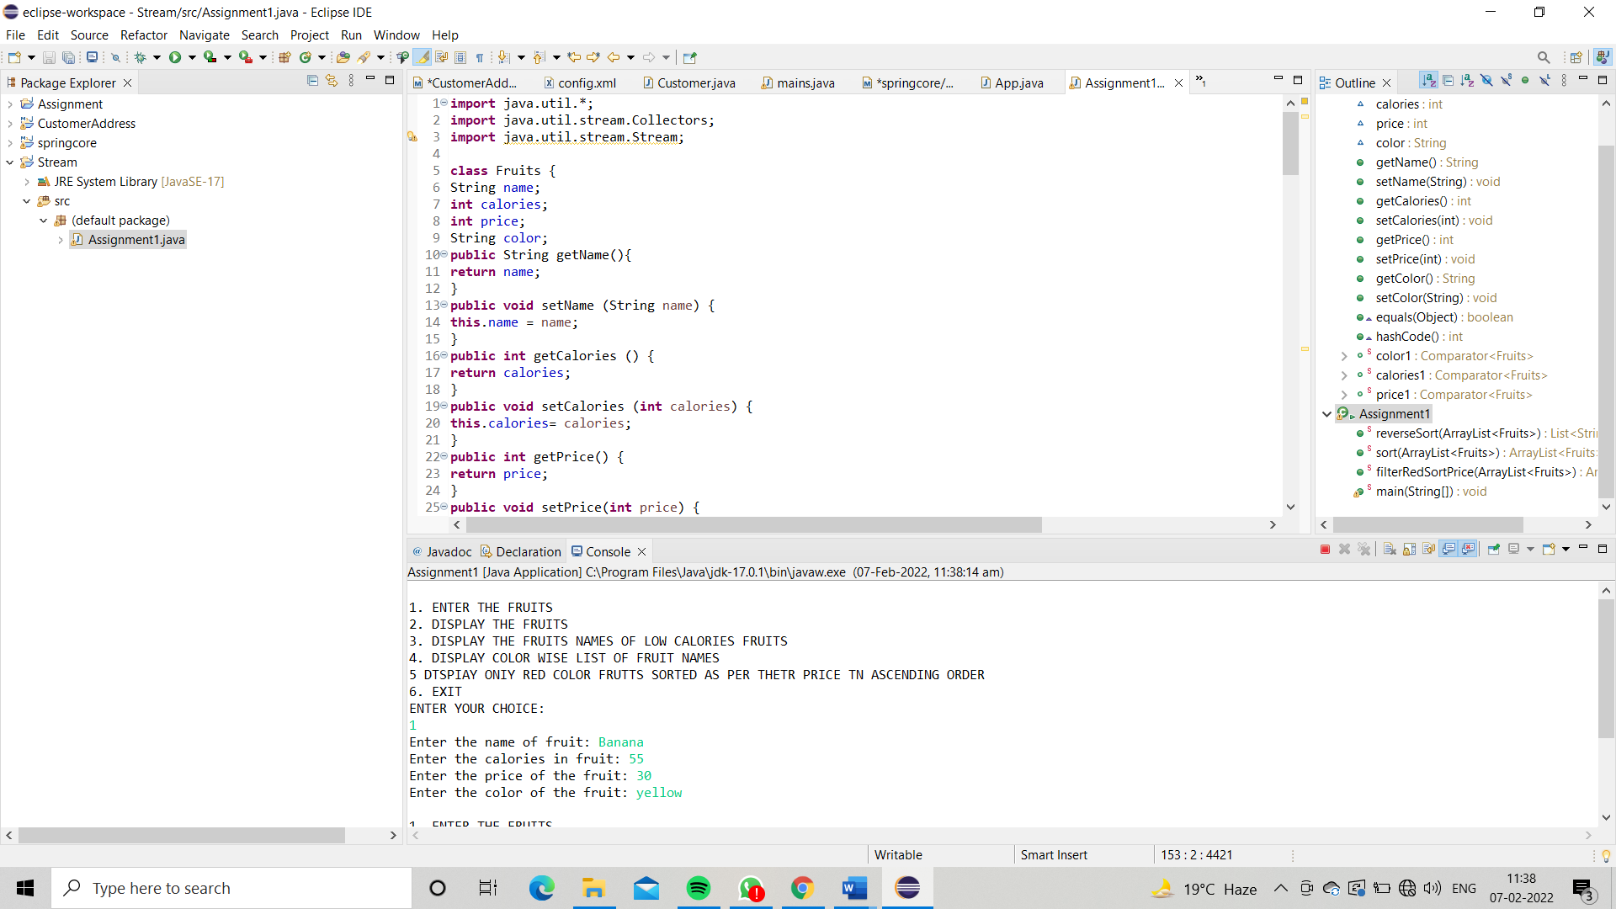

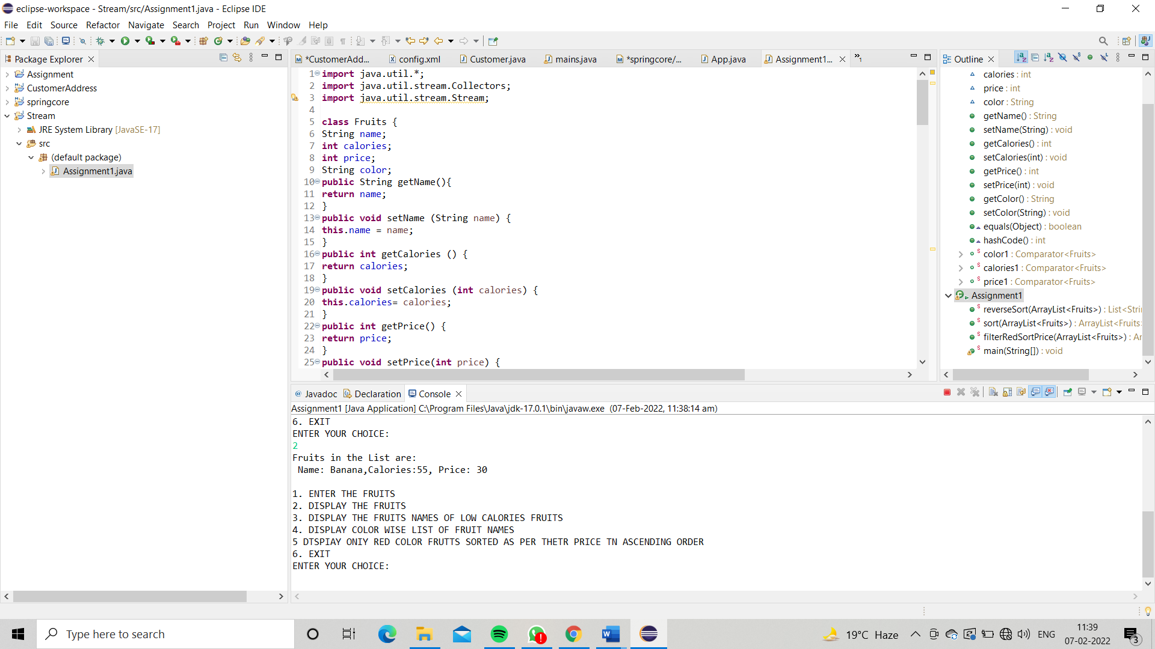

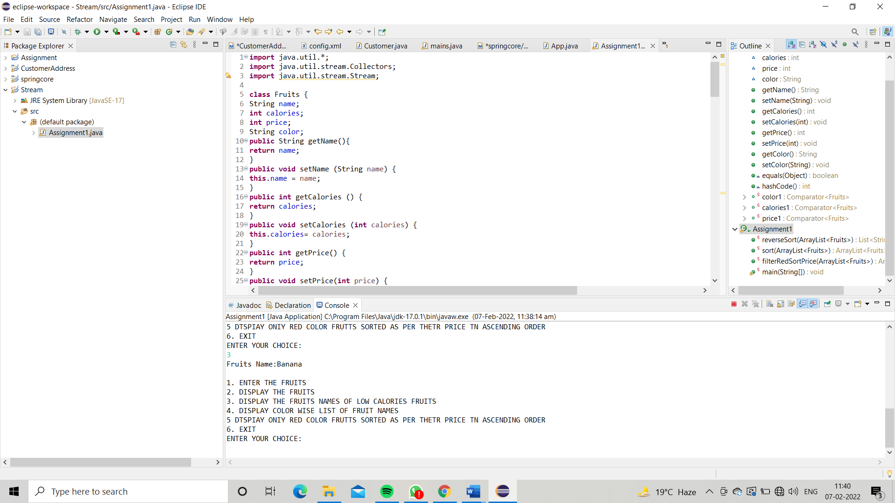

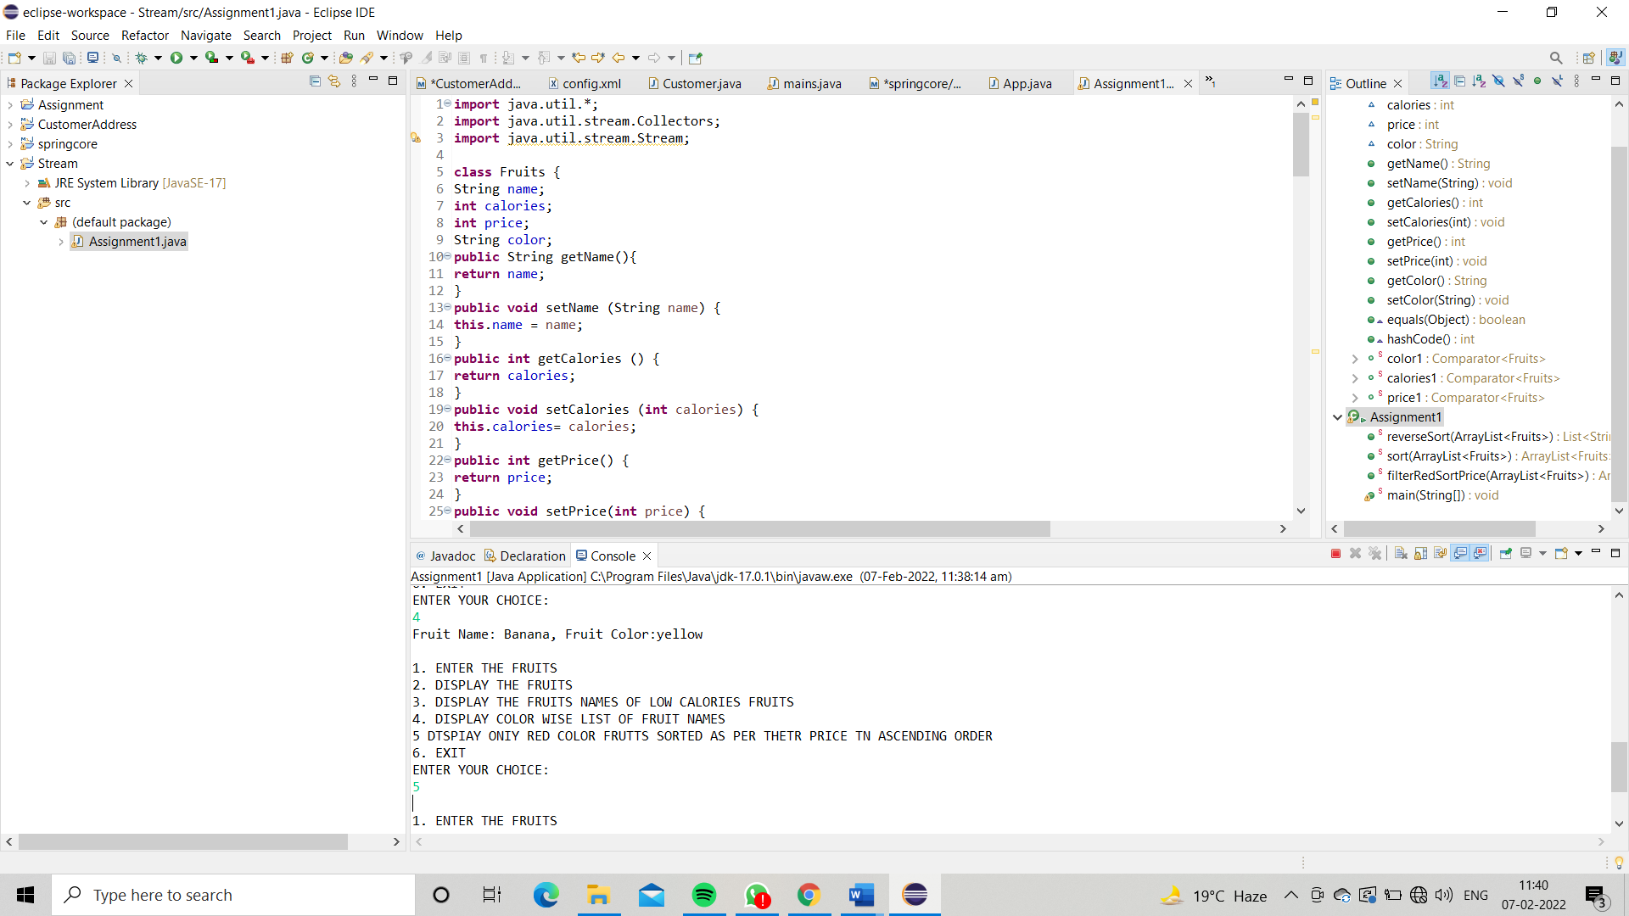

**Q2)Setup:**

Create the following classes:

class News { int newsId; String postedByUser; String commentByUser; String comment; }

Find Out:

1. Find out the newsId which has received maximum comments.

2. Find out how many times the word 'budget' arrived in user comments all news.

3. Find out which user has posted maximum comments.

4. Display commentByUser wise number of comments.

**import** java.util.*;

**import** java.util.stream.Collectors;

**class** News {

**int** newsId;

String postedByUser;

String commentByUser;

String comment;

**public** News(**int** newsId, String postedByUser, String commentByUser, String comment) {

**this**.newsId = newsId;

**this**.postedByUser = postedByUser;

**this**.commentByUser = commentByUser;

**this**.comment = comment;

}

**public** News() {

}

**public** **int** getNewsId() {

**return** newsId;

}

**public** **void** setNewsId(**int** newsId) {

**this**.newsId = newsId;

}

**public** String getPostedByUser(){

**return** postedByUser;

}

**public** **void** setPostedByUser (String postedByUser){

**this**.postedByUser= postedByUser;

}

**public** String getCommentByUser(){

**return** commentByUser;

}

**public** **void** setCommentByUser(String commentByUser) {

**this**.commentByUser= commentByUser;

}

**public** String getComment(){

**return** comment;

}

**public** **void** setComment (String comment) {

**this**.comment= comment;

}

@Override

**public** **boolean** equals (Object o) {

**if** (**this** == o) **return** **true**;

**if** (! (o **instanceof** News)) **return** **false**;

News news= (News) o;

**return** newsId== news.newsId&&commentByUser.equals(news.commentByUser)&&comment.equals(news.comment);

}

@Override

**public** **int** hashCode() {

**return** Objects.*hash*(newsId, commentByUser, comment);

}

}

**public** **class** AssignmentQ2{

**public** **static** **int** maxComments(List<News>news) {

Map<Integer, Integer>map = **new** HashMap<>();

**for**(News news1:news){

**int** id = news1.getNewsId();

**if**(map.containsKey(id)){

map.put(id,map.get (id)+1);

} **else** {

map.put (id,1);

}

}

List<Map.Entry<Integer, Integer>>list = **new** ArrayList<>(map.entrySet());

list.sort (Map.Entry.*comparingByValue*());

**return** list.get(list.size()-1).getKey();

}

**public** **static** **int** budgetCount(List <News >news) {

**int** count = 0;

List<String>list = **new** ArrayList<>();

**for** (News i: news){

String comment = i.getComment();

list.add(Arrays.*toString*(comment.split("budget")));

}

**return** list.size();

}

**public** **static** String maxCommentsByUser (List <News >news) {

Map<String, Integer>map = **new** HashMap<>();

**for** (News news1: news){

String username = news1.getCommentByUser();

**if**(map.containsKey (username)) {

map.put (username,map.get (username)+1);

}**else** {

map.put (username, 1);

}

}

List<Map.Entry<String, Integer>>list = **new** ArrayList<>(map.entrySet());

list.sort (Map.Entry.*comparingByValue*());

**return** list.get(list.size()-1).getKey();

}

**public** **static** Map<String, Integer>sortMaxCommentsByUser(List <News >news){

Map<String, Integer>map = **new** HashMap<>();

**for** (News news1: news){

String username = news1.getCommentByUser();

**if**(map.containsKey(username)){

map.put (username,map.get(username)+1);

} **else** {

map.put (username,1);

}

}

HashMap<String, Integer>temp

= map.entrySet()

.stream()

.sorted((i1, i2)

-›i2.getValue().compareTo(

i1.getValue()))

.collect(Collectors.toMap(

Map. Entry::getkey,

Map. Entry::getValue,

(e1, e2) -›e1, LinkedHashMap::**new**)) ;

**return** temp;

}

**public** **static** **void** main(String[] args) {

List<News>list = **new** ArrayList<>();

**int** choice;

Scanner sc= **new** Scanner (System.***in***);

News news1 = **new** News(1,

"Pradnya Badole",

"Mahima Dubey",

"I want to see the budegt");

News news2 = **new** News(1,

"Pradnya Baddole",

"Nivesh Banode",

"budget is my fundamental right");

News news3 = **new** News(2,

"Vaibhav Zade",

"Ayush Pansheriya",

"budget 2022");

list.add (news1);

list.add (news2) ;

list.add (news3);

**do** {

System.***out***.println("1. ENTER THE NEWS DETAILS");

System.***out***.println("2. DISPLAY THE NEWS DETAILS");

System.***out***.println("3. FIND OUT THE newsId WHICH HAS RECEIVED MAXIMUM COMMENTS.");

System.***out***.println("4. FIND OUT HOW MANY TIMES THE WORD 'BUDGET' ARRIVED IN USER COMMENTS ALL NEWS.");

System.***out***.println("5. FIND OUT WHICH USER HAS POSTED MAXIMUM COMMENTS.");

System.***out***.println("6. DISPLAY COMMENT BY USER WISE NUMBER OF COMMENTS.");

System.***out***.println("7. EXIT");

System.***out***.println("ENTER YOUR CHOICE:");

choice = sc.nextInt();

**switch** (choice){

**case** 1:

News news = **new** News();

**try** {

System.***out***.print("Enter the newsID: ");

**int** newId= sc.nextInt();

news.setNewsId(newId);

sc.nextLine();

System.***out***.print("Enter the name who posted the news: ");

String name = sc.nextLine();

news.setPostedByUser(name) ;

System.***out***.print("Enter the comment: ");

String comment = sc.nextLine();

news.setComment(comment) ;

System.***out***.print("Enter the name who posted the comment: ");

String username = sc.nextLine();

news. setCommentByUser(username) ;

list.add(news);

}**catch** (Exception e) {

System.***out***.println(e);

System.***out***.println("Enter the correct input please!!");

}

**break**;

**case** 2:**for** (News new1: list) {

System.***out***.println("News ID: "+new1.getNewsId());

System.***out***.println("News Posted By:"+new1.getPostedByUser());

System.***out***.println( "Comment by User:"+new1.getCommentByUser());

System.***out***.println("Comment Posted:"+new1.getComment());

System.***out***.println();

}

**break**;

**case** 3: **int** id = *maxComments* (list);

System.***out***.println("NEWS ID WHICH HAS RECEIVED MAXIMUM COMMENTS:"+id);

System.***out***.println();

**break**;

**case** 4: **int** countBudget= *budgetCount* (list);

System.***out***.println("HOW MANY TIMES THE WORD 'BUDGET' ARRIVED IN USER COMMENTS ALL NEWS: "+countBudget);

System.***out***.println();

**break**;

**case** 5: String name = *maxCommentsByUser* (list);

System.***out***.println("USER HAS POSTED MAXIMUM COMMENTS: "+name);

System.***out***.println();

**break**;

**case** 6: Map<String, Integer>maxCommentByUser= *sortMaxCommentsByUser*(list);

**for** (Map.Entry<String, Integer>mp: maxCommentByUser.entrySet()){

System.***out***.println("Name of the User: "+mp.getKey());

System.***out***.println("Numbers of Comments:"+mp.getValue());

System.***out***.println();

}

System.***out***.println();

**break**;

}

}**while** (choice!=7);

}

}

Output:

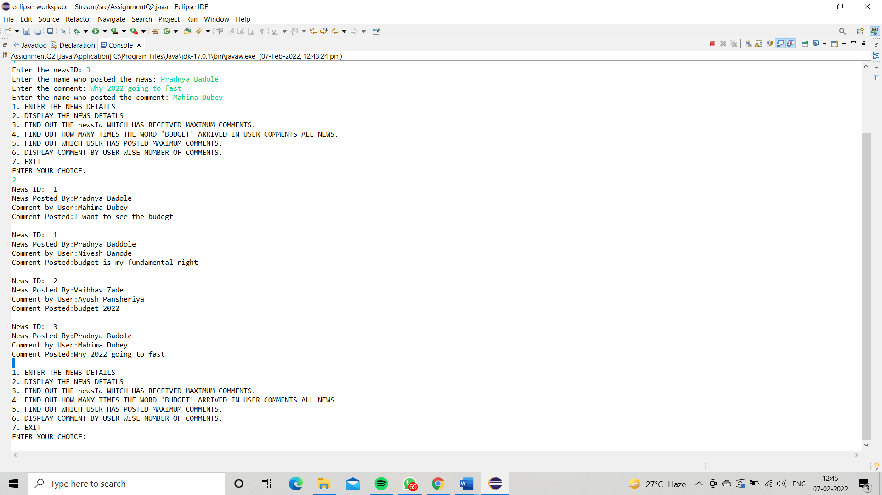

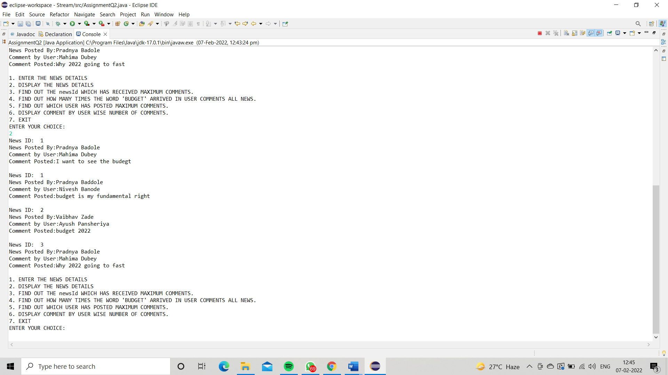

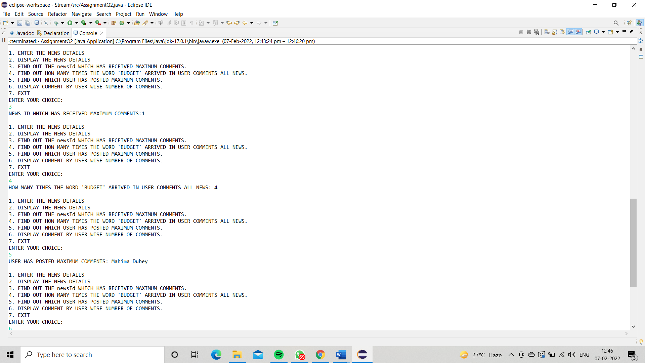

**Q3)Setup:**

Create the following classes:

class Trader { String name; String city; }

Find Out:

1. What are all the unique cities where the traders work?

2. Find all traders from Pune and sort them by name.

3. Return a string of all traders’ names sorted alphabetically.

4. Are any traders based in Indore?

Code:

**import** java.util.*;

**class** Trader {

String name;

String city;

**public** Trader(String name, String city) {

**this**.name = name;

**this**.city = city;

}

**public** Trader(){

}

**public** String getName() {

**return** name;

}

**public** **void** setName(String name) {

**this**.name = name;

}

**public** String getCity() {

**return** city;

}

**public** **void** setCity(String city) {

**this**.city = city;

}

@Override

**public** **boolean** equals(Object o) {

**if** (**this** == o) **return** **true**;

**if** (!(o **instanceof** Trader)) **return** **false**;

Trader trader= (Trader) o;

**return** name.equals(trader.name) &&city.equals(trader.city);

}

@Override

**public** **int** hashCode() {

**return** Objects.*hash*(name, city);

}

**public** **static** Comparator<Trader>*comparator* = **new** Comparator<Trader>() {

@Override

**public** **int** compare(Trader o1, Trader o2) {

**return** o1.getName().compareTo(o2.getName());

}

};

}

**public** **class** AssignmentQ3 {

**public** **static** List<String>printUniqueCities(List <Trader>traders) {

Map<String,String>map = **new** HashMap<>();

List<String>cities = **new** ArrayList<>();

**for** (Trader trader: traders){

map.putIfAbsent(trader.getCity(),trader.getName());

}

**for** (Map.Entry<String,String>mp: map.entrySet()){

cities.add(mp.getKey());

}

**return** cities;

}

**public** **static** List<String>tradersFromPuneSortByName(List<Trader>traders) {

List<String>tradersFromPune= **new** ArrayList<>();

**for** (Trader trader: traders){

**if**(trader.getCity().toUpperCase().equals("PUNE")){

tradersFromPune.add(trader.getName());

}

}

Collections.*sort*(tradersFromPune);

**return** tradersFromPune;

}

**public** **static** List<Trader>allTrader3Names(List<Trader>traders) {

traders.sort(Trader.*comparator*);

**return** traders;

}

**public** **static** ArrayList<Trader>areAnyTradersFromIndore(ArrayList<Trader>traders) {

ArrayList<Trader>traderList= **new** ArrayList<>();

**for**(Trader trader: traders){

**if**(trader.getCity().toUpperCase().equals("INDORE")){

traderList.add(trader);

}

}

**return** traderList;

}

**public** **static** **void** main(String[] args) {

Scanner sc= **new** Scanner(System.***in***);

ArrayList<Trader>arrayList= **new** ArrayList<>();

Trader trader1 = **new** Trader("Pradnya Badole","Texas");

Trader trader2 = **new** Trader("Mahima Dubey","Canada");

Trader trader3 = **new** Trader("Priyaka Banode","Dubai");

Trader trader4 = **new** Trader("Khusboo Patel","UK");

Trader trader5 = **new** Trader("Kalyani Malokar","Chicago");

Trader trader6 = **new** Trader("Sadicsha Khandait","New York");

arrayList.add(trader1);

arrayList.add(trader2);

arrayList.add(trader3);

arrayList.add(trader4);

arrayList.add(trader5);

arrayList.add(trader6);

**int** choice;

**do**{

System.***out***.println("\n1. ENTER THE TRADERS DETAILS");

System.***out***.println("2. DISPLAY THE TRADERS DETAILS");

System.***out***.println("3. DISPLAY ALL UNIQUE CITIES WHERE TRADERS WORK");

System.***out***.println("4. DISPLAY ALL TRADERS FROM PUNE SORTED BY NAME");

System.***out***.println("5. DISPLAY ALL TRADERS NAMES SORTED ALPHABETICALLY");

System.***out***.println("6. DISPLAY ALL TRADERS FROM INDORE");

System.***out***.println("7. EXIT");

System.***out***.println("ENTER YOUR CHOICE");

choice = sc.nextInt();

**switch** (choice){

**case** 1:

Trader trader= **new** Trader();

sc.nextLine();

System.***out***.println("Enter the Trader Name: ");

String name = sc.nextLine();

trader.setName(name);

System.***out***.println("Enter the City Name: ");

String city = sc.nextLine();

trader.setCity(city);

arrayList.add(trader);

**break**;

**case** 2:

System.***out***.println("List of traders: ");

**for** (Trader trade: arrayList){

System.***out***.println("Trader Name: "+trade.getName());

System.***out***.println("Trader City: "+trade.getCity());

}

System.***out***.println();

**break**;

**case** 3:

List<String>list = **new** ArrayList<>();

list = *printUniqueCities*(arrayList);

System.***out***.println("All uniques cities where traders work: ");

**for** (String str: list){

System.***out***.println(str);

}

System.***out***.println();

**break**;

**case** 4:

List<String>list1 = **new** ArrayList<>();

list1 = *tradersFromPuneSortByName*(arrayList);

System.***out***.println("All traders from Pune: ");

**for** (String str: list1){

System.***out***.println(str);

}

System.***out***.println();

**break**;

**case** 5: List<Trader>arraylist2 = **new** ArrayList<>();

arraylist2 = *allTrader3Names*(arrayList);

System.***out***.println("All Traders Name:");

**for**(Trader trader7: arraylist2){

System.***out***.println("Name: "+trader7.getName());

System.***out***.println("City: "+trader7.getCity());

System.***out***.println();

}

System.***out***.println();

**break**;

**case** 6: List<Trader>traderList= **new** ArrayList<>();

traderList= *areAnyTradersFromIndore*(arrayList);

System.***out***.println("All traders from Indore: ");

**for**(Trader trader7: traderList){

System.***out***.println("Name: "+trader7.getName());

}

System.***out***.println();

**break**;

**case** 7: System.*exit*(0);

**default**:

System.***out***.println("PLEASE ENTER THE RIGHT CHOICE!");

}

}**while** (choice!=7);

}

}

OUTPUT:

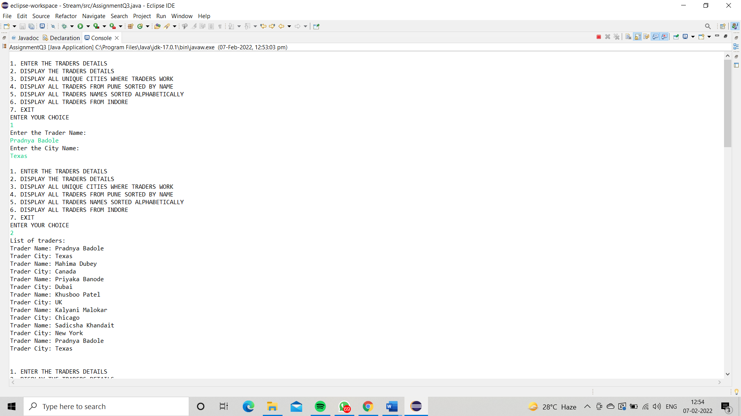

 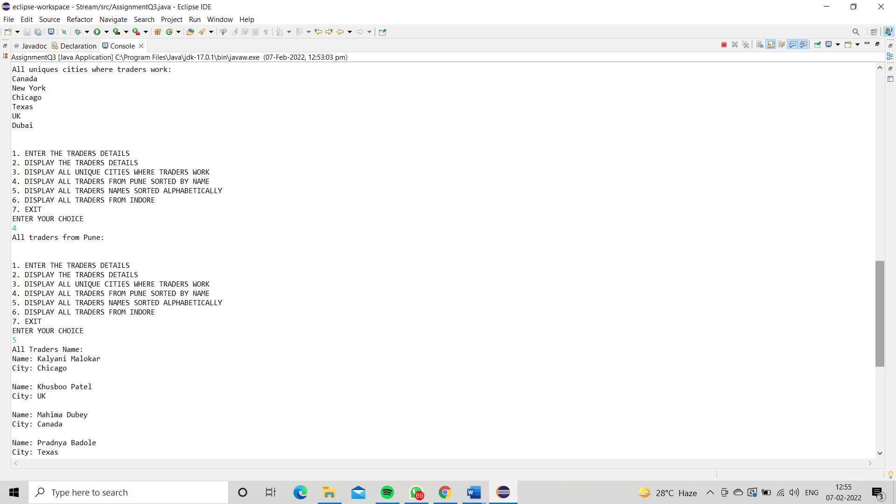

**Q4)Setup:**

Create the following classes:

class Trader { String name; String city; }

class Transaction { Tradertrader; int year; int value; }

1. Find all transactions in the year 2011 and sort them by value (small to high).

2. Print all transactions’ values from the traders living in Delhi.

3. What’s the highest value of all the transactions?

4. Find the transaction with the smallest value.

Code: **import** java.util.*;

**import** java.util.stream.Collectors;

**class** Trader1 {

String name;

String city;

**public** Trader1(String name, String city) {

**this**.name = name;

**this**.city = city;

}

**public** Trader1(){

}

**public** String getName() {

**return** name;

}

**public** **void** setName(String name) {

**this**.name = name;

}

**public** String getCity() {

**return** city;

}

**public** **void** setCity(String city) {

**this**.city = city;

}

@Override

**public** **boolean** equals(Object o) {

**if** (**this** == o) **return** **true**;

**if** (!(o **instanceof** Trader1)) **return** **false**;

Trader1 trader1 = (Trader1) o;

**return** name.equals(trader1.name) &&city.equals(trader1.city);

}

@Override

**public** **int** hashCode() {

**return** Objects.*hash*(name, city);

}

}

**class** Transaction {

Trader1 trader1;

**int** year;

**int** value;

**public** Transaction(){}

**public** Transaction(Trader1 trader1, **int** year, **int** value) {

**this**.trader1 = trader1;

**this**.year = year;

**this**.value = value;

}

**public** Trader1 getTrader1() {

**return** trader1;

}

**public** **void** setTrader1(Trader1 trader1) {

**this**.trader1 = trader1;

}

**public** **int** getYear() {

**return** year;

}

**public** **void** setYear(**int** year) {

**this**.year = year;

}

**public** **int** getValue() {

**return** value;

}

**public** **void** setValue(**int** value) {

**this**.value = value;

}

@Override

**public** **boolean** equals(Object o) {

**if** (**this** == o) **return** **true**;

**if** (!(o **instanceof** Transaction)) **return** **false**;

Transaction that = (Transaction) o;

**return** year == that.year &&value == that.value &&trader1.equals(that.trader1);

}

@Override

**public** **int** hashCode() {

**return** Objects.*hash*(trader1, year, value);

}

**public** **static** Comparator<Transaction>*MaximumValue* = **new** Comparator<Transaction>() {

@Override

**public** **int** compare(Transaction o1, Transaction o2) {

**return** o1.getValue()-o2.getValue();

}

};

}

**public** **class** AssignmentQ4 {

**public** **static** List<Transaction>sortTransactions(List <Transaction>transactions) {

transactions = transactions.stream().filter((t1)->t1.getYear()==2011).collect(Collectors.*toList*());

transactions.sort(Transaction.*MaximumValue*);

**return** transactions;

}

**public** **static** List<Integer>transactionsValuesDelhi(List<Transaction>transactions) {

List<Integer>transactionValue = **new** ArrayList<>();

transactions = transactions.stream().filter((t1)->t1.getTrader1().getCity().toUpperCase().equals("DELHI")).collect(Collectors.*toList*());

**for**(Transaction t1: transactions){

transactionValue.add(t1.getValue());

}

**return** transactionValue;

}

**public** **static** **int** highestTransaction(List<Transaction>transactions){

**int** MaxTransaction;

MaxTransaction = transactions.stream().mapToInt(Transaction::getValue).max().orElseThrow(NoSuchElementException::**new**);

**return** MaxTransaction;

}

**public** **static** **int** smallestTransaction(List<Transaction>transactions){

**return** transactions.stream().mapToInt(Transaction::getValue).min().orElseThrow(NoSuchElementException::**new**);

}

**public** **static** **void** main(String[] args) {

List<Transaction>arraylist = **new** ArrayList<>();

Scanner sc= **new** Scanner(System.***in***);

**int** choice;

**do**{

System.***out***.println("1. ENTER THE DETAILS OF TRADERS & THEIR TRANSACTIONS");

System.***out***.println("2. DISPLAY THE DETAILS OF TRADERS & THEIR TRANSACTION");

System.***out***.println("3. DISPLAY ALL TRANSACTIONS IN THE YEAR 2011 IN SORTED ORDER");

System.***out***.println("4. DISPLAY ALL TRANSACTIONS FROM TRADERS WHO LIVES IN DELHI");

System.***out***.println("5. DISPLAY THE HIGHEST VALUE OF ALL THE TRANSACTIONS");

System.***out***.println("6. DISPLAY THE SMALLEST VALUE OF ALL THE TRANSACTIONS");

System.***out***.println("7. EXIT");

System.***out***.println("ENTER YOUR CHOICE");

choice = sc.nextInt();

**switch** (choice){

**case** 1:

Transaction transaction = **new** Transaction();

Trader1 trader1= **new** Trader1();

sc.nextLine();

System.***out***.print("ENTER THE NAME OF THE TRADER: ");

String name = sc.nextLine();

trader1.setName(name);

System.***out***.print("ENTER THE CITY NAME OF THE TRADER: ");

String city = sc.nextLine();

trader1.setCity(city);

transaction.setTrader1(trader1);

System.***out***.print("ENTER THE YEAR OF TRANSACTION: ");

**int** year = sc.nextInt();

transaction.setYear(year);

System.***out***.print("ENTER THE AMOUNT OF TRANSACTION: ");

**int** amount = sc.nextInt();

transaction.setValue(amount);

arraylist.add(transaction);

**break**;

**case** 2:

System.***out***.println("List of all Traders and their Transactions");

**for** (Transaction t: arraylist){

System.***out***.println("Trader Name: "+t.getTrader1().getName());

System.***out***.println("Trader City: "+t.getTrader1().getCity());

System.***out***.println("Year: "+t.getYear());

System.***out***.println("Value: "+t.getValue());

System.***out***.println();

}

**break**;

**case** 3:

System.***out***.println("All the transactions in the year 2011 in sorted order: ");

List<Transaction>transactionList = **new** ArrayList<>();

transactionList = *sortTransactions*(arraylist);

**for** (Transaction t1: transactionList){

System.***out***.println("Trader Name: "+t1.getTrader1().getName());

System.***out***.println("Trader City: "+t1.getTrader1().getCity());

System.***out***.println("Value: "+t1.getValue());

System.***out***.println("Year: "+t1.getYear());

System.***out***.println();

}

**break**;

**case** 4:

System.***out***.println("All transactions from the traders lives in Delhi: ");

List<Integer>list = **new** ArrayList<>();

list = *transactionsValuesDelhi*(arraylist);

list.forEach(System.***out***::println);

**break**;

**case** 5: **int** Maxvalue = *highestTransaction*(arraylist);

System.***out***.println("Highest Transaction value: "+Maxvalue);

**break**;

**case** 6: **int** Minvalue = *smallestTransaction*(arraylist);

System.***out***.println("Lowest Transaction value: "+Minvalue);

**break**;

**case** 7: System.*exit*(0);

**default**:

System.***out***.println("PLEASE ENTER THE CORRECT CHOICE: ");

}

}**while** (choice!=7);

}

}

Output:

